**Screenshot of the project:**

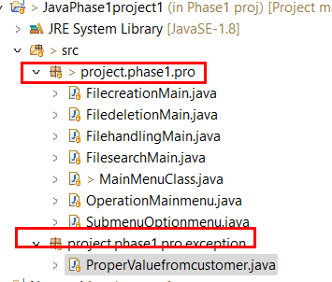

Project is created under 2 package **project.phase1.pro** and **project.phase1.pro.exception** and it has total **8 classes**

**Please find the Screenshot of the classes:**

1. Main class contain Main Method: **OperationMainmenu.java**

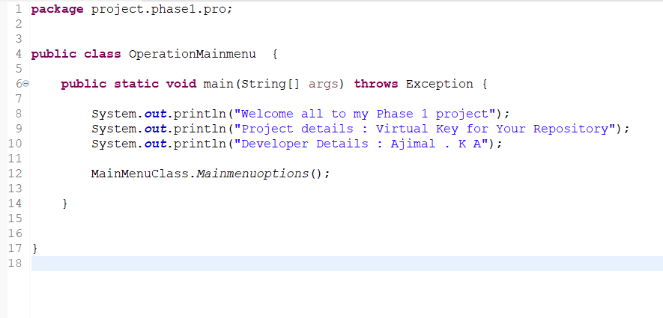

2)Main menu handling: **MainMenuClass.java**

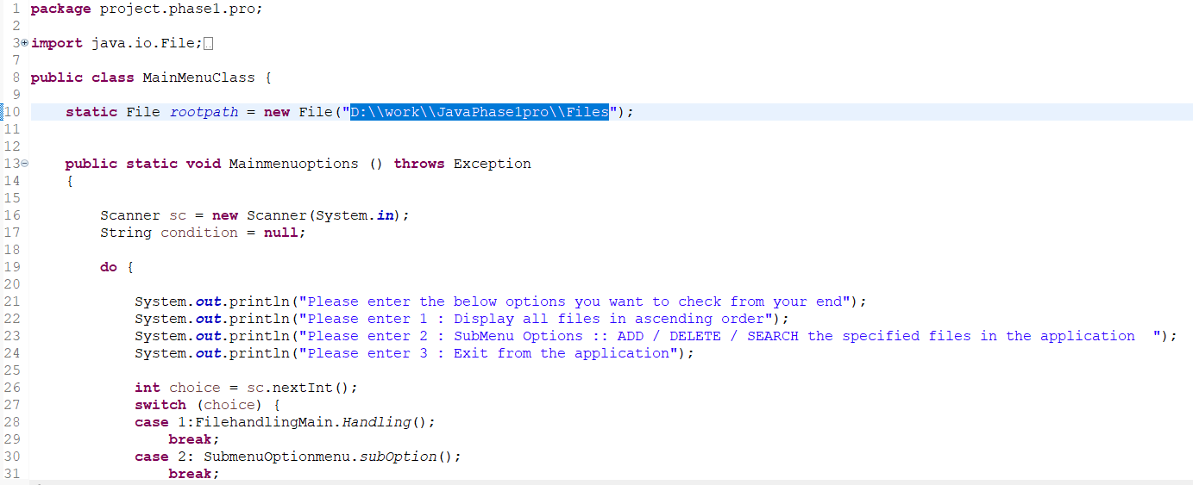

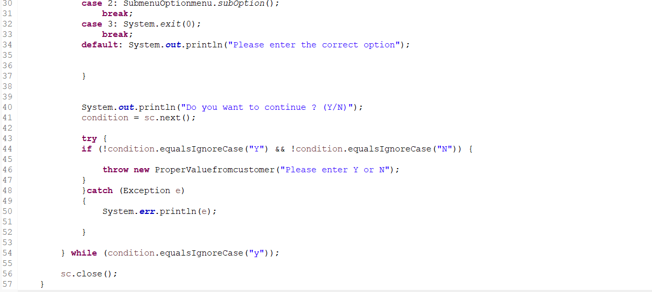

3)Submenu Handling: **SubmenuOptionmenu.java**

Here the Submenu is created under the IF-ELSE-IF statement and which is iterating under the While loop

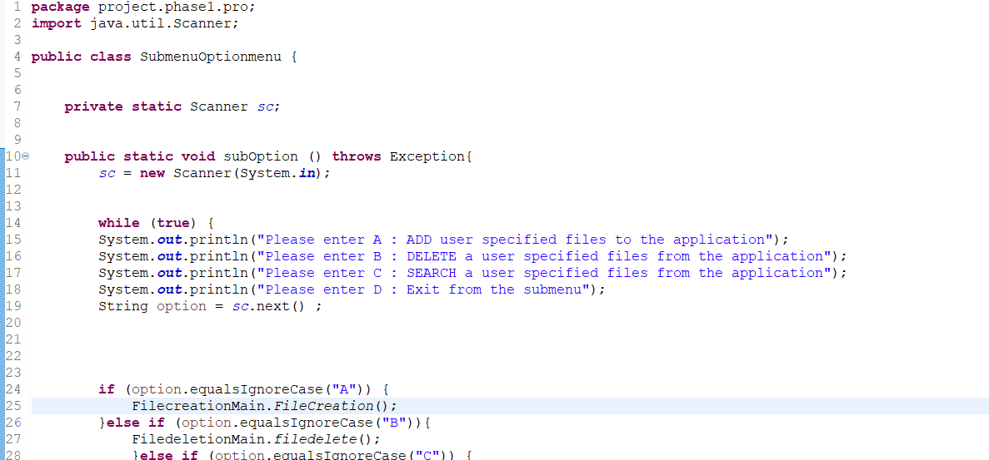

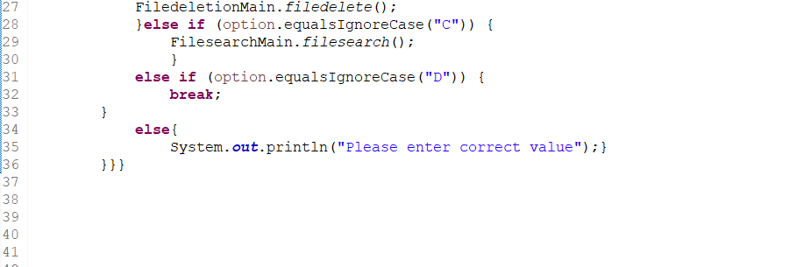

**4)** Files in ascending order: **FilehandlingMain.java**

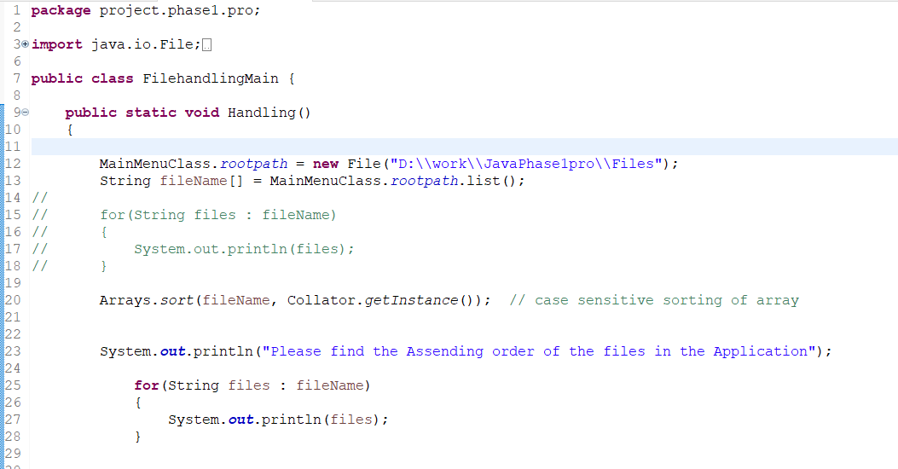

**5)** File creation Class: **FilecreationMain.java**

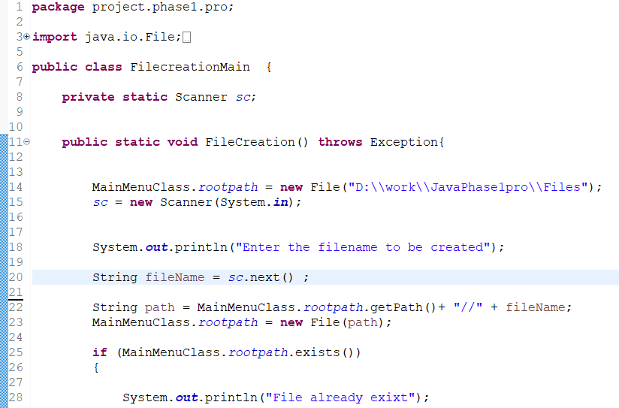

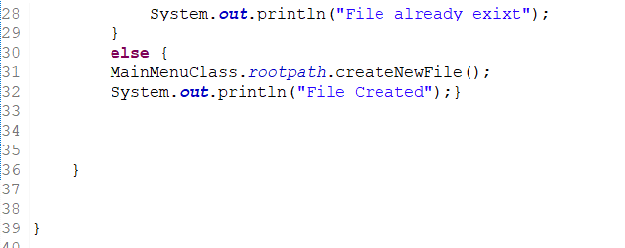

**6)** File deletion class: **FiledeletionMain.java**

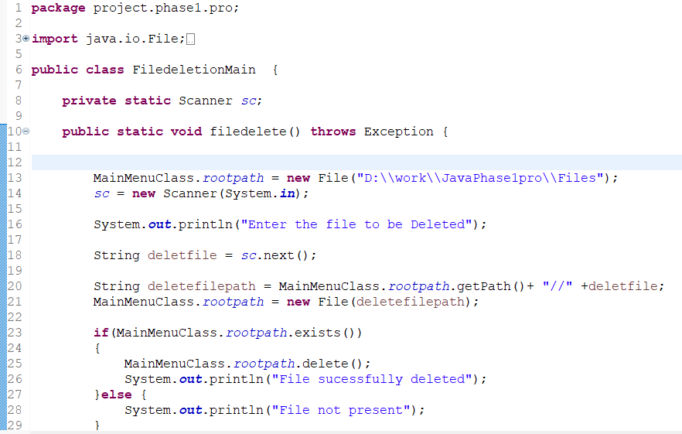

7)File Search Class: **FilesearchMain.java**

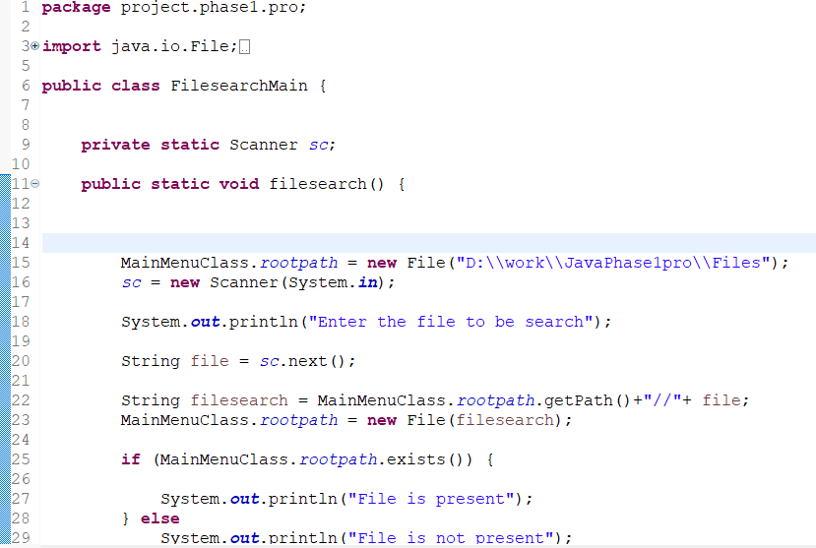

**8)** File Exception: **ProperValuefromcustomer.java**

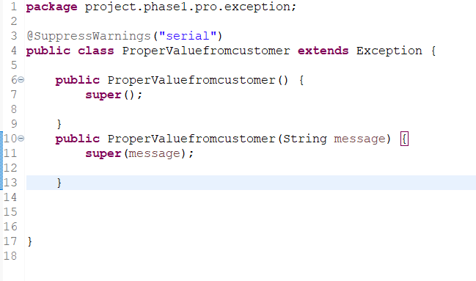

**The Output from the Project.**

Initial Page:

This gives the introduction of the project and provides the Main menu options.

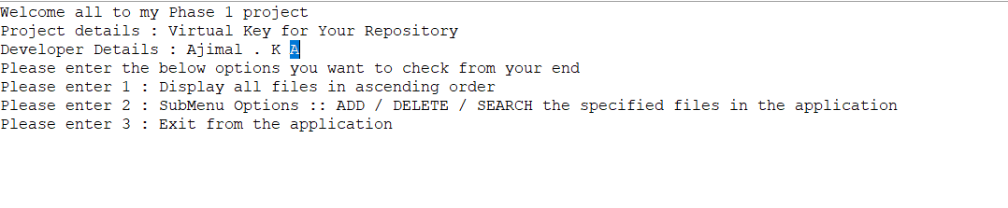

If I enters 1:-

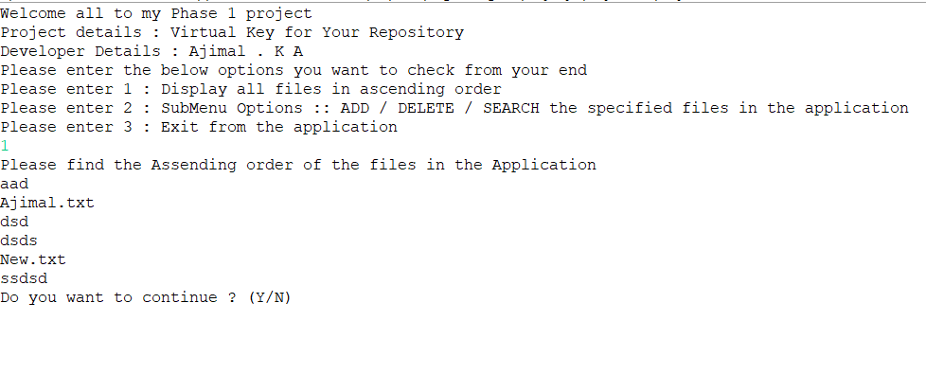It will give the ascending order of the files in the folder ignoring upper case or Lower case, you want to continue or not, if you enter- y, it will again redirect to main menu

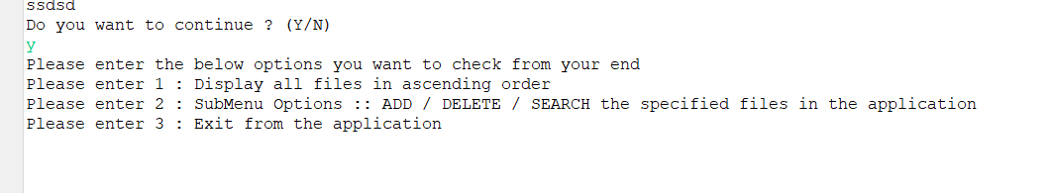

If I enters 2, it will move to Submenu option.

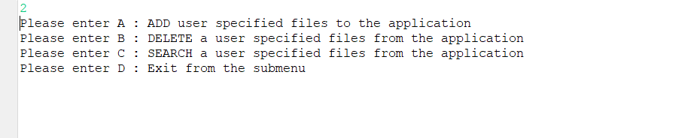submenu option will as Addition, Deletion Seach and exit out of submenu option.

If enter A- It will create a fille and again came back to Submenu option.

It will loop only inside the submenu option, unless and until if we type D to exit from the Submenu.

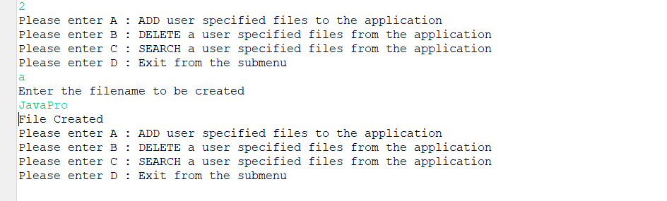

If we enters B, it will search for the file there to delete and if file Is there, it will delete and if file is not there, it will inform no file present and again came back to Submenu option.

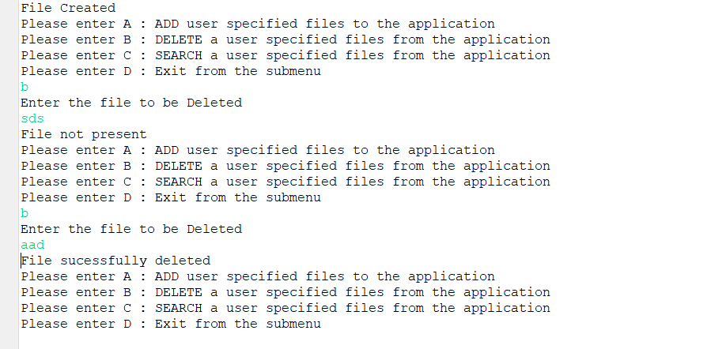

Same way, if we enters C, it will search the file is there or not.

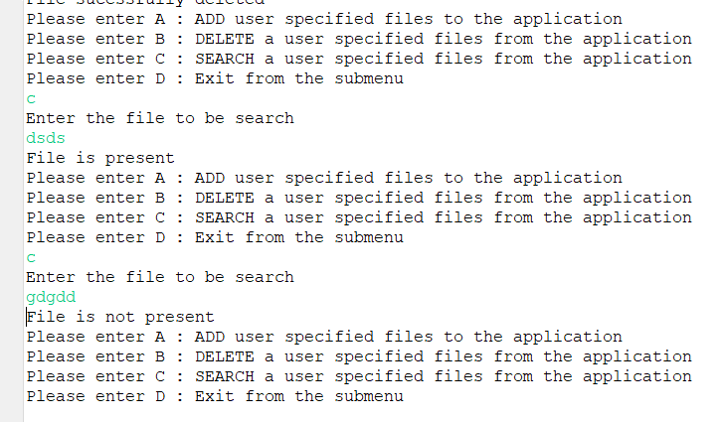

If we enter, apart from A,B,C,D, It will ask to enter correct value.

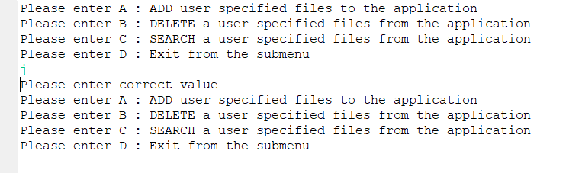

And after enter- D, it will exit out of Submenu and ask “ you want to continue or not”. If we press Y, it will move to Main menu.

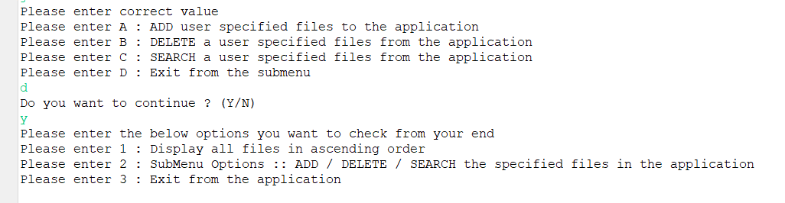

If we enters 3, it will exit out of the application (Program).

If we enter apart from Y or N, Custom Exception will generate and ask user to enter only Y or N.

